# Tugas Pemrograman Berorientasi Objek



**Muhamad Salman Adhim Baqy**

**A11.2020.12641**

**Fakultas Ilmu Komputer**

**Program Studi Teknik Informatika**

**Universitas Dian Nuswantoro**

**2022**

1. Hasil Output

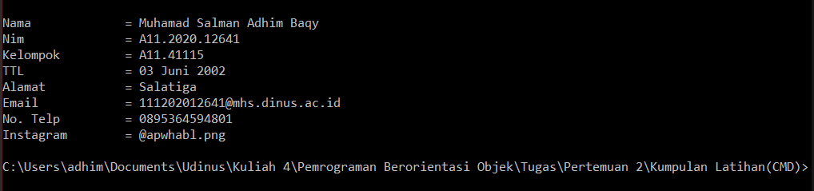

Source Code

|  |
| --- |
| public class Latihan1 {  public static void main(String[] args) {  System.out.println("\n");  String nama = "Muhamad Salman Adhim Baqy";  String nim = "A11.2020.12641";  String kelompok = "A11.41115";  String ttl = "03 Juni 2002";  String alamat = "Salatiga";  String email = "111202012641@mhs.dinus.ac.id";  String noTelp = "0895364594801";  String instagram = "@apwhabl.png";    System.out.println("Nama\t\t = "+ nama);  System.out.println("Nim\t\t = "+ nim);  System.out.println("Kelompok\t = "+ kelompok);  System.out.println("TTL\t\t = "+ ttl);  System.out.println("Alamat\t\t = "+ alamat);  System.out.println("Email\t\t = "+ email);  System.out.println("No. Telp\t = "+ noTelp);  System.out.println("Instagram\t = "+ instagram);  }    } |

1. Hasil Output

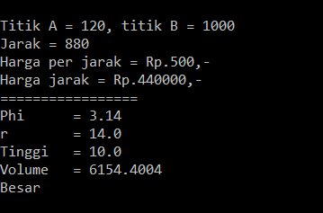

Source Code

|  |
| --- |
| public class Latihan23 {  public static void main(String[] args) {  System.out.println("\n");  int A = 120; int B = 1000;  System.out.println("Titik A = "+ A +", titik B = 1000");  int jarak = B - A;  System.out.println("Jarak = "+ jarak);  int perJarak = 500;  System.out.println("Harga per jarak = Rp."+perJarak+",-");  System.out.println("Harga jarak = Rp."+ jarak*perJarak+",-");    System.out.println("=================");    float phi = 3.14f;  float jariJari = 14.0f;  float tinggi = 10.0f;    System.out.println("Phi\t = "+phi);  System.out.println("r\t = "+jariJari);  System.out.println("Tinggi\t = "+tinggi);    float volume = phi* jariJari * jariJari *tinggi;  System.out.println("Volume\t = "+ volume);  if(volume >= 1000){  System.out.println("Besar");  }else System.out.println("Kecil");    }    } |

1. Hasil Output

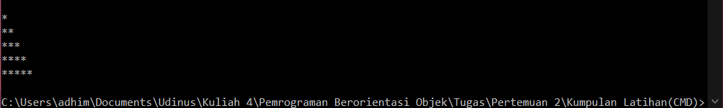

Source Code

|  |
| --- |
| public class Latihan3 {  public static void main(String[] args) {  System.out.println("\n");  for(int i = 0; i < 5; i++){  for(int j = 0; j < i; j++ ){  System.out.print("*");  }  System.out.println("*");  }  }  } |